SECTION 8:

DBMS 05.8.24

--------------------------GROUP FUNCTIONS---------------------------------------------

8.1 SECTION

1.MAX

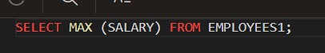



2.MIN



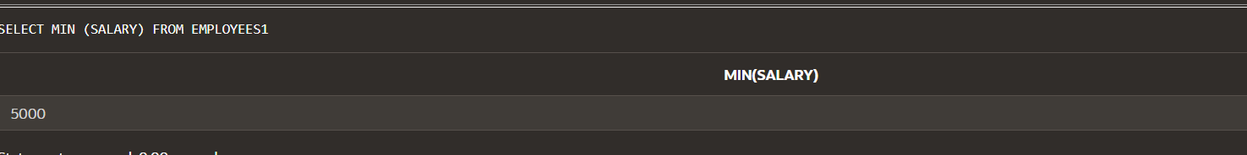

3.SUM

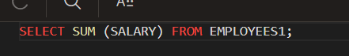

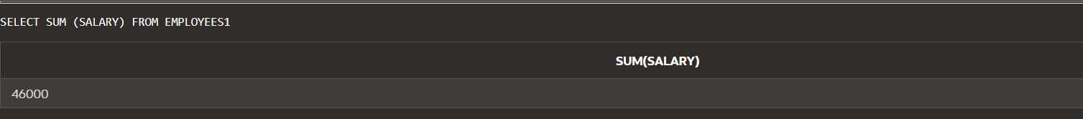

4.AVG





5.VARIANCE



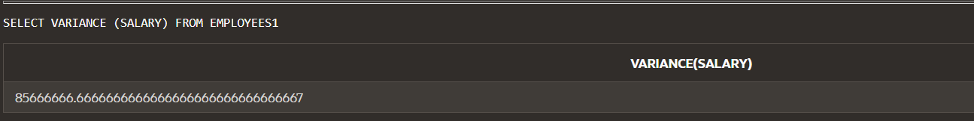

6.STDDEV

4

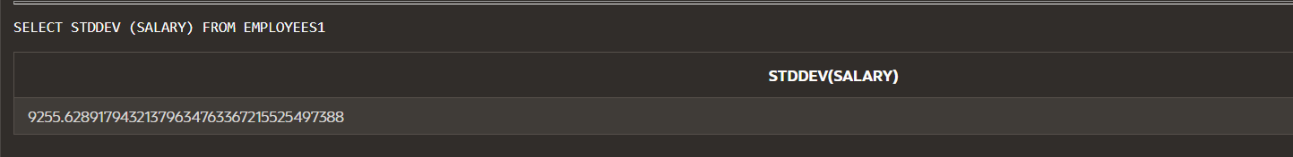

7.COUNT



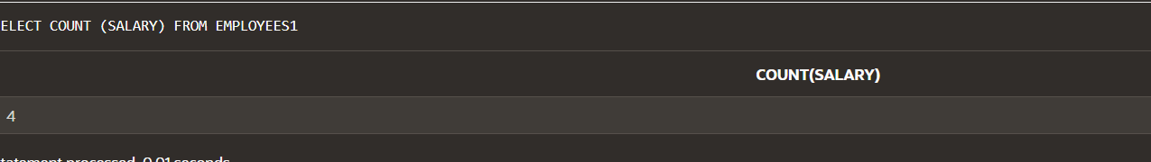

8.MORE THAN ONE GROUP FUNCTION

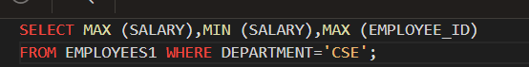



8.2 SECTION

1.COUNT

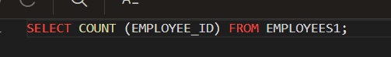

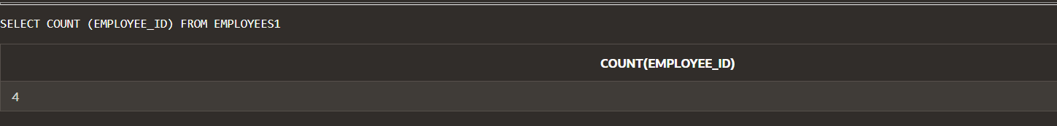

2.DISTINCT



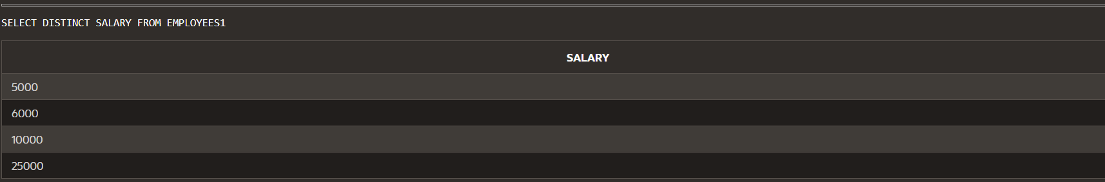

3.USING DISTINCT



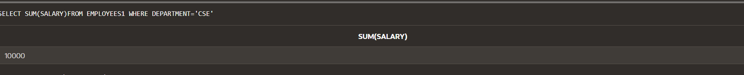

4.NVL

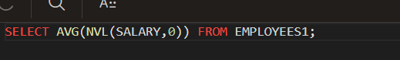

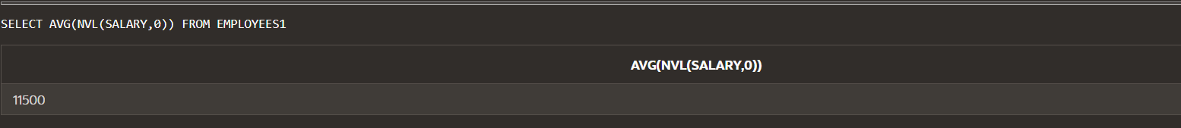

9.1 GROUP BY

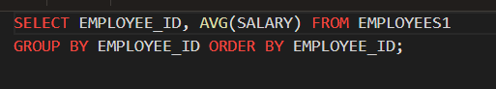

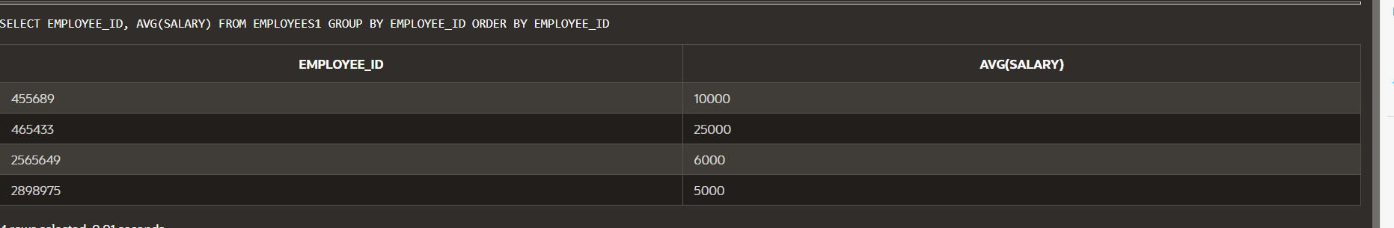

2.GROUP BY IN SELECT



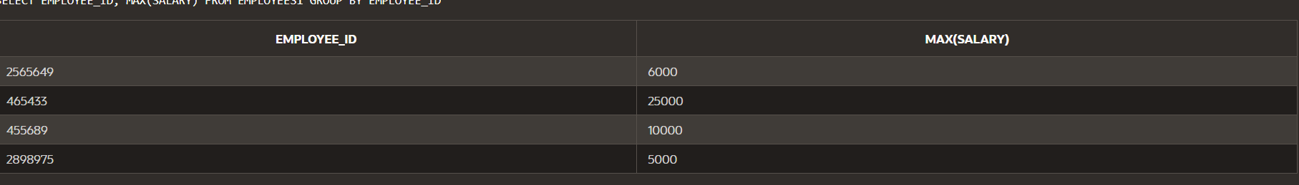

3.WHERE CLAUSE

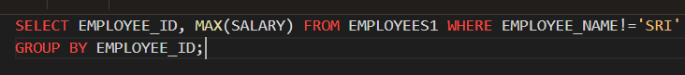

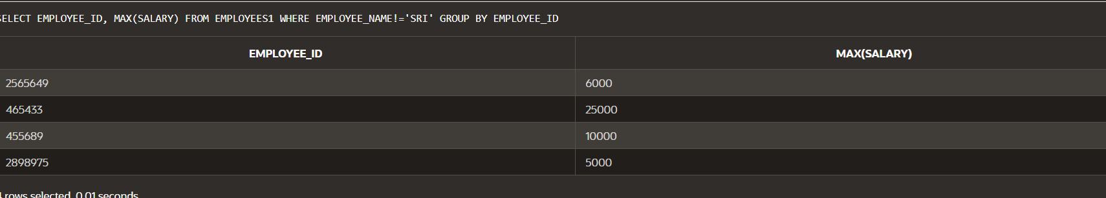

4.MORE GROUP BY

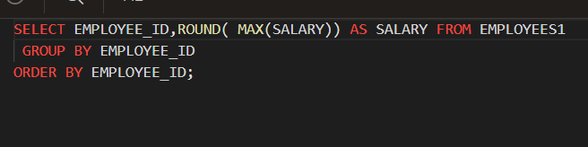

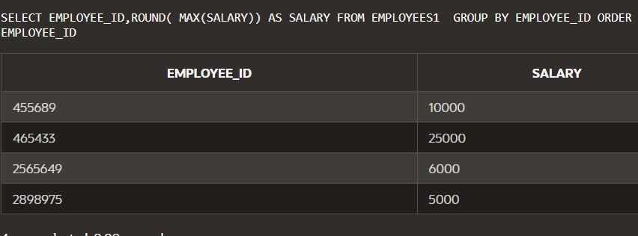

5.GROUP WITHIN GROUPS

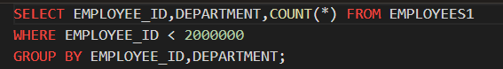

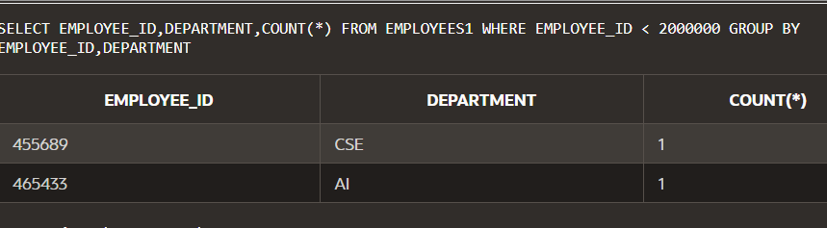

6.NESTING GROUP FUNCTIONS

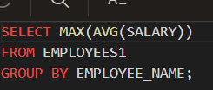

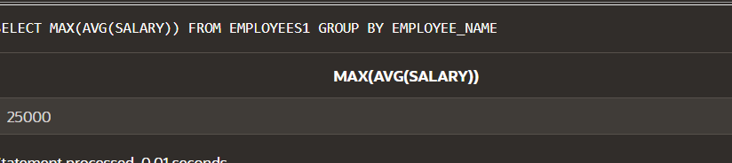

7.HAVING

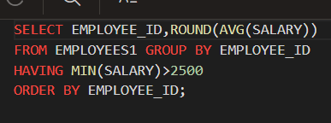

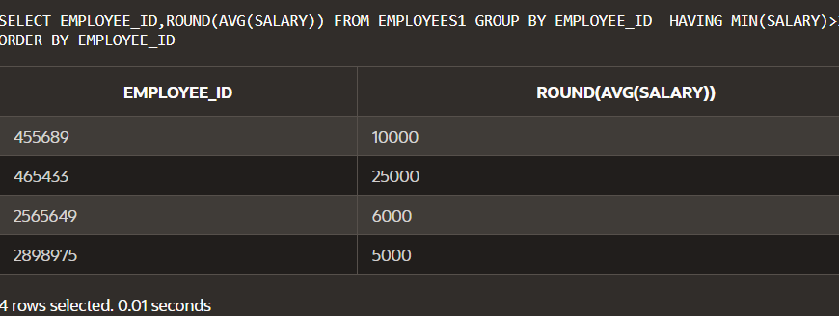

9.2 ROLLING UP AND CUBING UP

ROLLUP

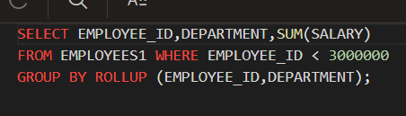

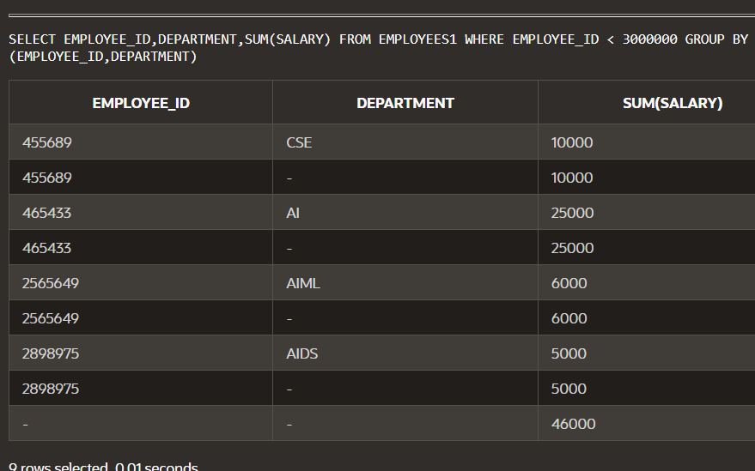

WITHOUT ROLLUP

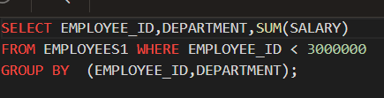

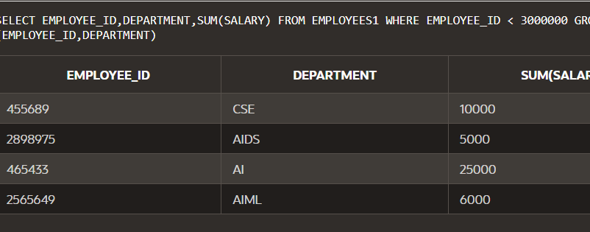

CUBE

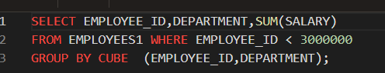

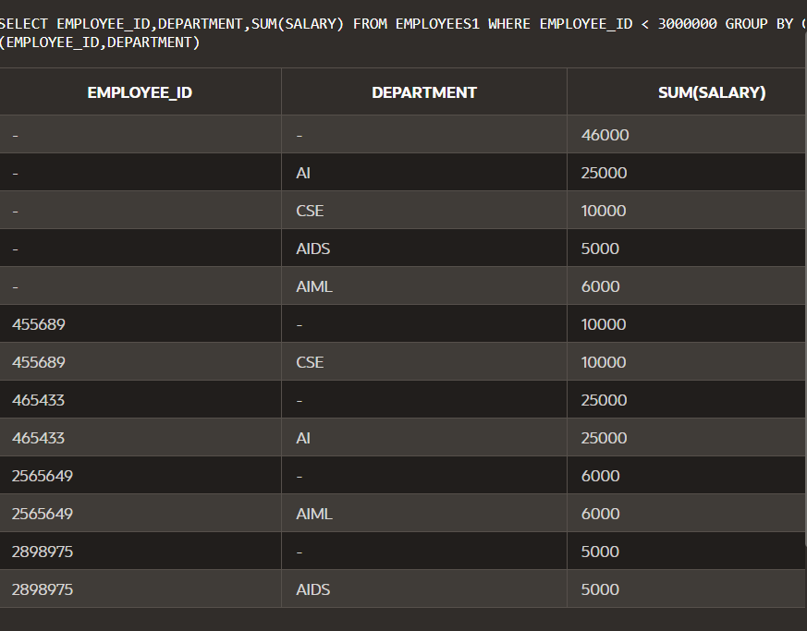

GROUPING SETS

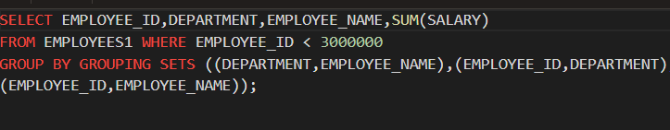

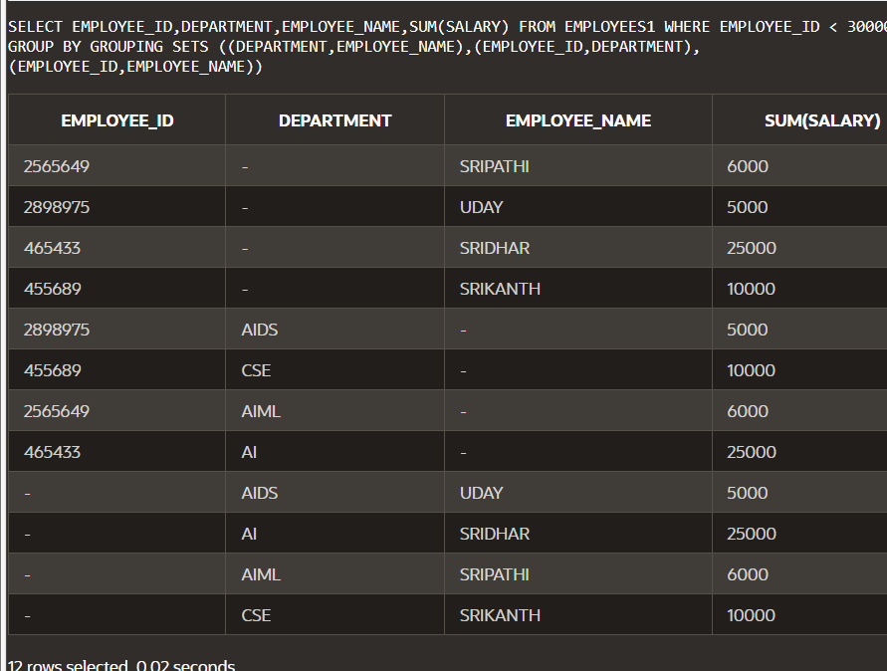

06.08.24

Section 9.3

Union

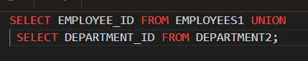

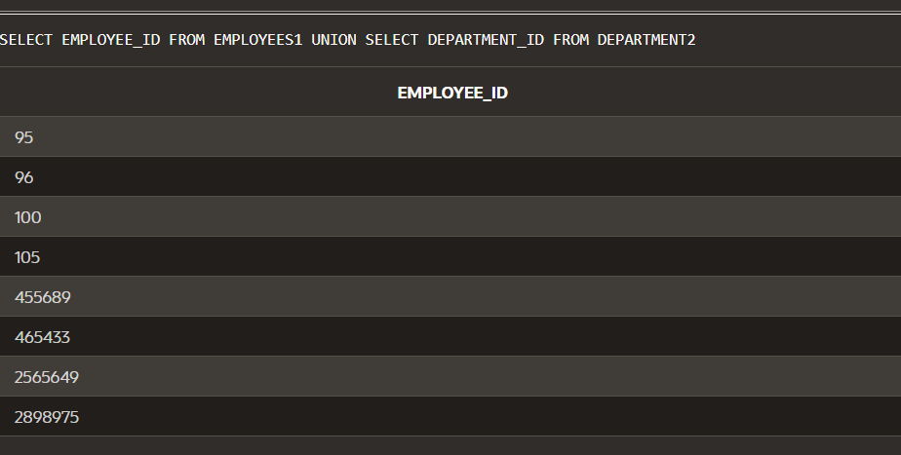

UNION ALL

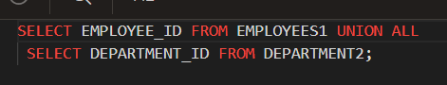

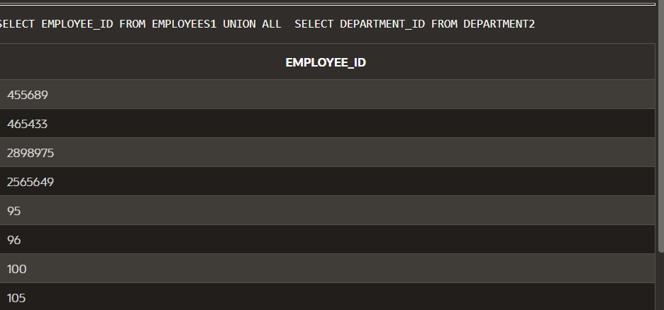

INTERSECT

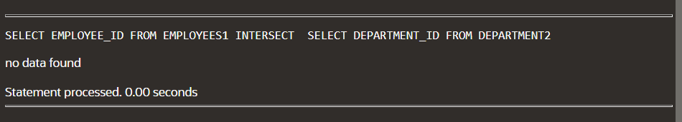

MINUS

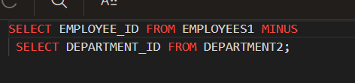

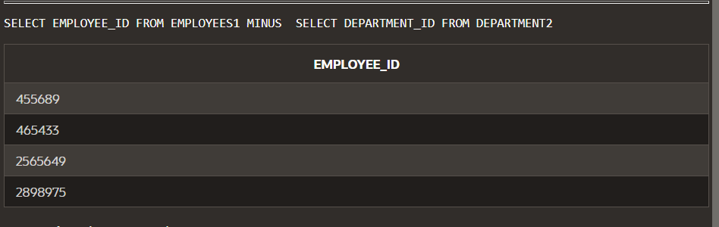

SET OPERATOR EXAMPLES

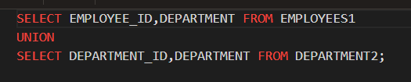

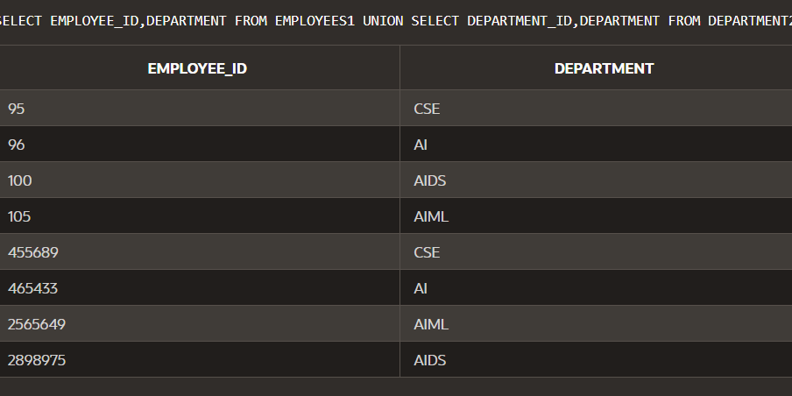

SET OPERATORS USING ORDER BY

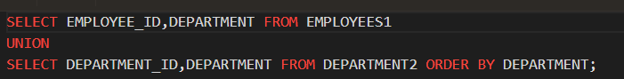

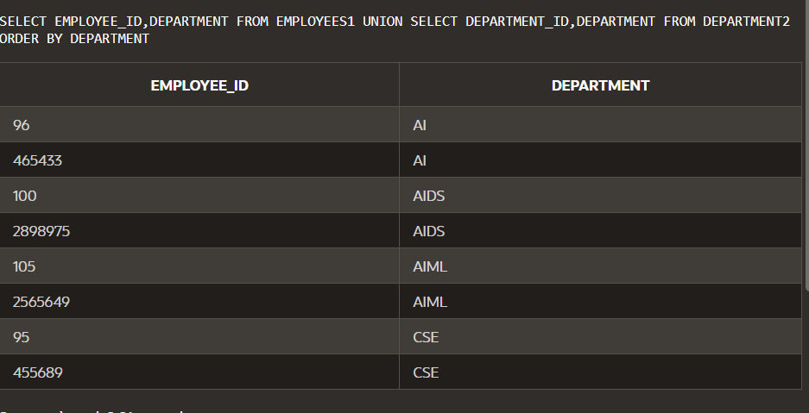

10.1 FUNDAMENTAL OF SUBQUERIES IN TABLE 2

SUBQUERY OVERVIEW

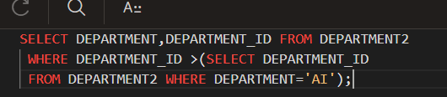

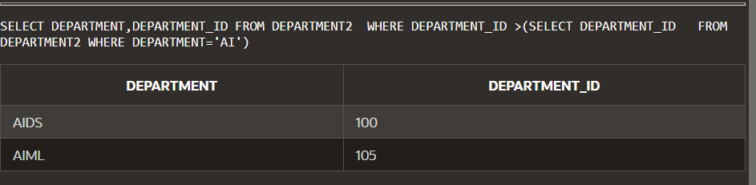

SUBQUERY AND NULL

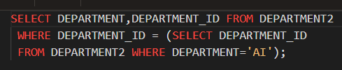

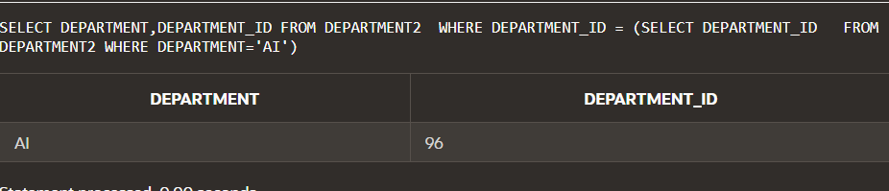

07.08.24

New examples of tables

Security based

NEW TABLE CREATE

